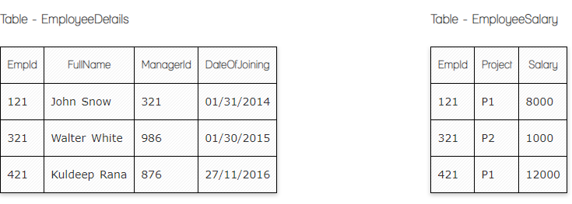

**Ques.1. Write a SQL query to fetch the count of employees working in project 'P1'.**

**My Answer:**

SELECT COUNT(Project)

FROM EmployeeSalary

WHERE Project='P1';

**Ques.2. Write a SQL query to fetch employee names having salary greater than or equal to 5000 and less than or equal 10000.**

**My Answer:**

SELECT EmployeeDetails.FullName

FROM EmployeeSalary

INNER JOIN EmployeeDetails ON EmployeeDetails.EmpId = EmployeeSalary.EmpId

WHERE Salary >=5000

AND Salary <=10000;

**Ques.3. Write a SQL query to fetch count of employees sorted by project's count in descending order.**

**My Answer:**

SELECT COUNT(Project), COUNT(EmpId)

FROM EmployeeSalary

GROUP BY Project

ORDER BY COUNT(Project) DESC;

**Ques.4. Write a query to fetch employee names and salary records. Return employee details even if the salary record is not present for the employee.**

**My Answer:**

SELECT EmployeeDetails.FullName, EmployeeSalary.Salary

FROM EmployeeSalary

RIGHT JOIN EmployeeDetails ON EmployeeSalary.EmpId= EmployeeDetails.EmpId;

**Ques.5. Write a SQL query to create an empty table with ‘Test’ name.**

**My Answer:**

CREATE TABLE Test (

ID int NOT NULL AUTO_INCREMENT PRIMARY KEY,

FirstName varchar(20) NOT NULL,

LastName varchar(20),

PhoneNumber char(9),

DateOfJoining date

);

**Ques.6. Write a SQL query to delete an empty table with ‘Test’ name.**

**My Answer:**

DROP TABLE Test;

**Ques.7. Write a SQL query to fetch all the Employees details from EmployeeDetails table who joined in Year 2016.**

**My Answer:**

SELECT *

FROM EmployeeDetails

WHERE YEAR(DateOfJoining) = 2016;

**Ques.8. Write a SQL query to insert new record to the EmployeeDetails table with any data.**

**My Answer:**

INSERT INTO EmployeeDetails (FullName, ManagerId, DateOfJoining)

VALUES ('Sonya Ghazaryan', '999', '2018-12-08');

**Ques.9. Write a SQL query to update EmployeeSalary table with setting Salary to 2000 for Project P2.**

**My Answer:**

UPDATE EmployeeSalary

SET Salary = '2000'

WHERE Project = 'P2';

**Ques.10. Write a SQL query to right join both tables and draw the results.**

**My Answer:**

SELECT *

FROM EmployeeSalary

RIGHT JOIN EmployeeDetails ON EmployeeSalary.EmpId= EmployeeDetails.EmpId;

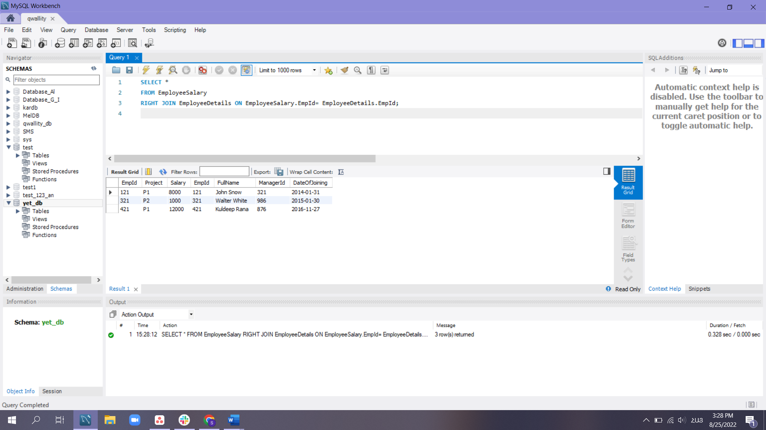

**users addresses**

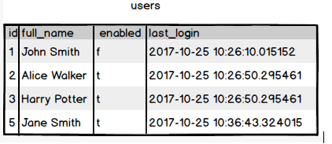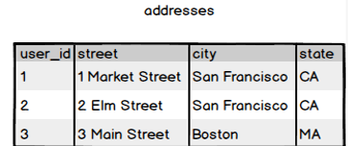

**Ques.11. Write a SQL query to fetch all users full_name from San Francisco.**

**My Answer:**

SELECT users.full_name

FROM addresses

INNER JOIN users ON addresses.user_id= users.id

WHERE city='San Francisco';

**Ques.12. Write a SQL query to fetch all users full_name, last_login who are enabled**

**My Answer:**

SELECT full_name, last_login

FROM users

WHERE enabled='t';

**Ques.13. Write a SQL query to fetch all users full_name who are not from Main Street**

**My Answer:**

SELECT users.full_name

FROM addresses

INNER JOIN users ON addresses.user_id= users.id

WHERE NOT street='Main Street';

**Ques.14. Write a SQL query to fetch all users full_name who are from Main Street or San Francisco**

**My Answer:**

SELECT users.full_name

FROM addresses

INNER JOIN users ON addresses.user_id= users.id

WHERE city='San Francisco' OR street='Main Street';

**Ques.15. Write a SQL query to fetch user full_name who is equal to user_id from Boston (find user_id value in sub_query)**

**My Answer:**

SELECT full_name FROM users

WHERE id =

(SELECT user_id

FROM addresses

WHERE city='Boston');